Getting Started with GitHub/GitLab

# Download git

Git is the backbone upon which both GitHub and GitLab are built (hence their names). You will need to download this software in order to use either of them.

Download from: <https://git-scm.com/downloads>

## Make an account: GitHub

Navigate to: [www.github.com](http://www.github.com)

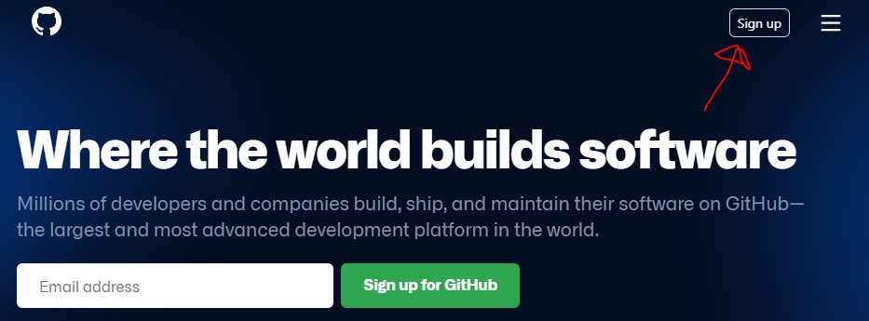

## Or make an account: GitLab

Navigate to: <https://about.gitlab.com/>

